# **Creating Microservices for account and loan**

This document demonstrates the creation of two independent Spring Boot RESTful microservices:

* **Account Microservice**
* **Loan Microservice**

Each microservice is created as a Maven project and runs independently on different ports.

**Account Microservice**

**Project Details**:

* **Group**: com.cognizant
* **Artifact**: account
* **Dependencies**: Spring Web, Spring Boot DevTools
* **Port**: 8082

**AccountApplication.java:**

package com.cognizant.account;  
import org.springframework.boot.SpringApplication;  
import org.springframework.boot.autoconfigure.SpringBootApplication;  
  
@SpringBootApplication  
public class AccountApplication {  
  
 public static void main(String[] args) {  
 SpringApplication.*run*(AccountApplication.class, args);  
 }  
  
}

**AccountController.java:**

package com.cognizant.account;

import org.springframework.web.bind.annotation.GetMapping;

import org.springframework.web.bind.annotation.PathVariable;

import org.springframework.web.bind.annotation.RestController;

import java.util.HashMap;

import java.util.Map;

@RestController

public class AccountController {

@GetMapping("/accounts/{number}")

public Map<String, Object> getAccountDetails(@PathVariable String number) {

Map<String, Object> response = new HashMap<>();

response.put("number", "00987987973432");

response.put("type", "savings");

response.put("balance", 234343);

return response;

}

}

**application.properties:**

spring.application.name=account  
server.port=8082

**Output:**

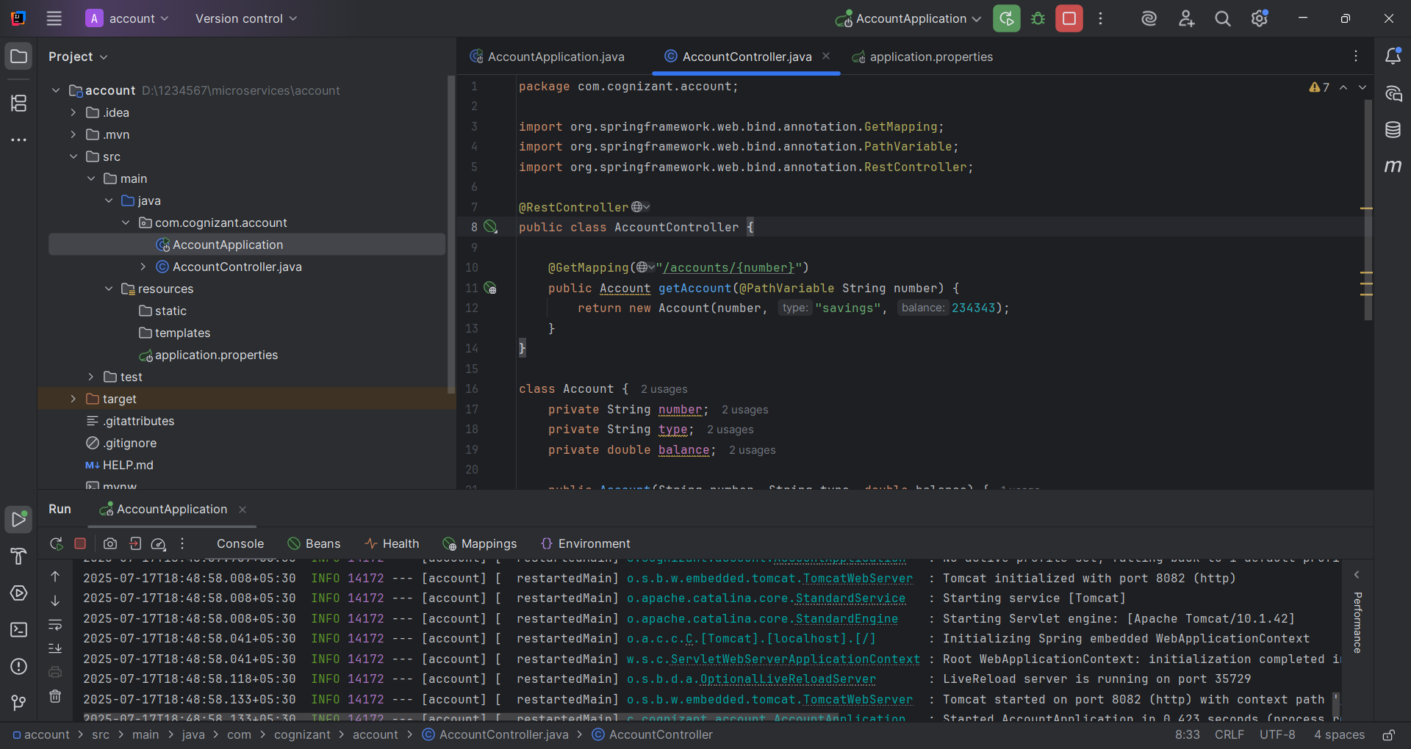

**Loan Microservice**

**Project Details**:

* **Group**: com.cognizant
* **Artifact**: loan
* **Dependencies**: Spring Web, Spring Boot DevTools
* **Port**: 8081

**LoanApplication.java:**

package com.cognizant.loan;

import org.springframework.boot.SpringApplication;

import org.springframework.boot.autoconfigure.SpringBootApplication;

@SpringBootApplication

public class LoanApplication {

public static void main(String[] args) {

SpringApplication.run(LoanApplication.class, args);

}

}

**LoanController.java:**

package com.cognizant.loan;

import org.springframework.web.bind.annotation.GetMapping;

import org.springframework.web.bind.annotation.PathVariable;

import org.springframework.web.bind.annotation.RestController;

import java.util.HashMap;

import java.util.Map;

@RestController

public class LoanController {

@GetMapping("/loans/{number}")

public Map<String, Object> getLoanDetails(@PathVariable String number) {

Map<String, Object> response = new HashMap<>();

response.put("number", "H00987987972342");

response.put("type", "car");

response.put("loan", 400000);

response.put("emi", 3258);

response.put("tenure", 18);

return response;

}

}

**application.properties:**

spring.application.name=loan  
server.port=8081

**OUTPUT:**

Two independent microservices were successfully created and run on different ports. Each exposes a REST API and responds with dummy data, simulating real-world account and loan services.